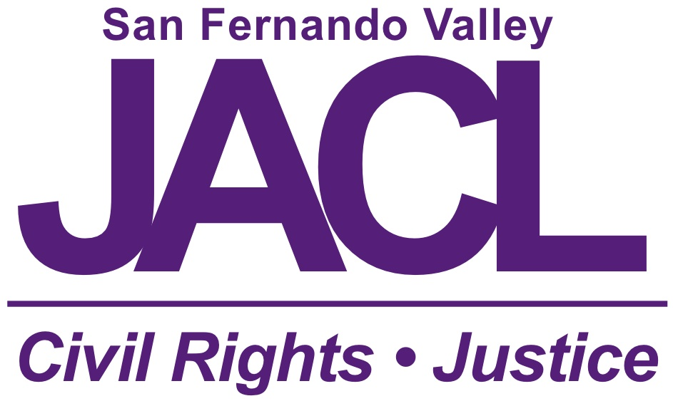
For Office Use Only
2022 SFV JACL FRESHMAN SCHOLARSHIP

DESCRIPTION:
The SFV JACL Scholarship supports outstanding graduating high school seniors with interests in social justice and civil rights. The award is administered by the San Fernando Valley chapter of the Japanese American Citizens League (JACL), the nation’s oldest and largest Asian American civil rights organization.

GENERAL REQUIREMENTS:
- Applicants must hold student membership in the San Fernando Valley chapter of the JACL. Students are welcome to apply for membership with their scholarship application. To apply for student/youth membership, please see jacl.org/membership for more details and remember to select “San Fernando Valley.” Do not send a check to the chapter with your application.
- Minimum GPA of 3.2.
- Service to one's school, local, and Japanese American and/or Asian American communities.

MATERIALS REQUIRED: All applications are submitted ONLINE. We are accepting E-transcripts or transcripts, letter(s) of recommendation, photos as PDF/JPG/PNG.
- One copy of the application (see pages 2-4).
- One copy of an official transcript that includes fall semester grades. Submitted as PDF.
- One letter of recommendation from a teacher, counselor, school administrator, employer, or community leader. The letter must be submitted with this application.
- One photograph for use in scholarship program and other materials.

APPLICATION INSTRUCTIONS:
- Sections A and B: Fill out the required information on the application.
- Sections C through G - Use separate WORD document. ATTACH documents to application. To ensure the best consideration, make sure to copy-edit and proofread all documents.
- Do not include this cover page in your application.

- GENERAL INFORMATION - Please print clearly.

Name (Last, First, MI)
Email Address _________________________________Phone No.
Permanent Address
City __________________________ State ____ Zip Code _________ Cell No.
JACL Membership Number: _________ (National JACL will give you a receipt)
Check here if from a single parent household: □ Is that parent your sole financial support? Yes No
- ACADEMIC HISTORY
Please list all colleges/universities you have applied to for this fall, indicate the current status from the institution (accepted, denied, or pending), and list your intended major (if undecided, list “undecided”). Place an asterisk next to the institution you have decided to attend if you have made your decision.
Institution(s) applied for FALL | Status from Institution | Intended Major
Overall GPA (unweighted, based on 4.0 scale):
Academic GPA (unweighted, based on 4.0 scale):
Please list your high school attended (if more than one, beginning with most current).
Institution Name | Dates Attended | GPA

C. PERSONAL STATEMENT
The JACL is moving toward its 100th Anniversary with a renewed commitment to educating the public about the World War II incarceration of Japanese Americans and combating anti-Asian hate. What steps have you taken to learn about the Japanese American incarceration experience: How can we use education as a tool to not only correct past historical narratives, but to also move forward towards promoting a greater social consciousness within our society.

D. COMMUNITY INVOLVEMENT
List all relevant service to your local community and the larger Asian American community. Indicate years of participation, positions held, and awards received.
E. SCHOLASTIC HONORS
List all academic awards, prizes, or scholarships earned during high school.
F. EXTRACURRICULAR ACTIVITIES
List all campus activities, indicating the year of the activity, leadership positions held, and non- academic awards received. You may include information on project based or group learning. Please include awards for attendance, fundraising for school, and other non-academic achievements.
G. WORK HISTORY
List dates and job titles of all work experience, if any.
APPLICATION PROCESSING
- Please submit one copy of your completed application, including all supporting documents and official transcripts.
- Notification of receipt will be via email after applications are received.
- Completed applications must be EMAILED to:

May Wood, Scholarship Co-Chair
may.wood66@yahoo.com

ALL APPLICATIONS MUST BE POSTMARKED OR EMAILED BY May 20, 2022, 11:59 pm FOR CONSIDERATION.

AWARDS LOGISTICS
Awardees will receive their scholarships depending on the status of the pandemic; details will be announced. If we continue to hold VIRTUAL meetings, scholarship recipients will be invited the SFV JACL EXECUTIVE BOARD MEETING.

FOR MORE INFORMATION
Please note that the SFV JACL SCHOLARSHIP is administered separately from the San Fernando Valley JACC scholarships. Applicants should direct all inquiries to:

May Wood Jean-Paul deGuzman
SFV JACL Scholarship Co-Chair SFV JACL Scholarship Co-Chair
may.wood66@yahoo.com deguzman.ucla@gmail.com
818 399-7221
To learn more about the San Fernando Valley JACL, please go to: http://sfvjacl.weebly.com/

AGREEMENT
I have read and fully understand the eligibility requirements and information requested for the SFV JACL Scholarship. I have completed the application honestly and to the best of my knowledge. I fully understand that any misrepresentation of information contained in this application may revoke any rights to an award. I also understand that if I am selected for an award, verification of enrollment is required before any monies can be disbursed. If for any reason I do not matriculate at a post-secondary school, I will forfeit any rights to an award.

Signature of Applicant | Date

